**Designing a Chatbot Using IBM Cloud Watson Assistant**

**Phase 1: Problem Definition and Design Thinking**

# Problem Definition

The project involves creating a chatbot using IBM Cloud Watson Assistant with the primary goal of developing a virtual guide that assists users on messaging platforms such as Facebook Messenger and Slack. The chatbot should provide valuable information, answer frequently asked questions (FAQs), and offer a friendly and engaging conversational experience. The project encompasses several key aspects:

1. **Persona Design:** Define the chatbot's persona, including its name, tone, and style of communication.
2. **User Scenarios:** Identify common user scenarios and frequently asked questions that the chatbot should be able to address effectively.
3. **Conversation Flow:** Design the conversation flow, outlining how the chatbot responds to various user queries and prompts.
4. **Response Configuration:** Configure the chatbot's responses using Watson Assistant's intents, entities, and dialog nodes to ensure accurate and context-aware interactions.
5. **Platform Integration:** Integrate the chatbot seamlessly with popular messaging platforms like Facebook Messenger and Slack.
6. **User Experience:** Ensure a seamless and user-friendly experience, with clear prompts and informative responses that enhance user satisfaction.

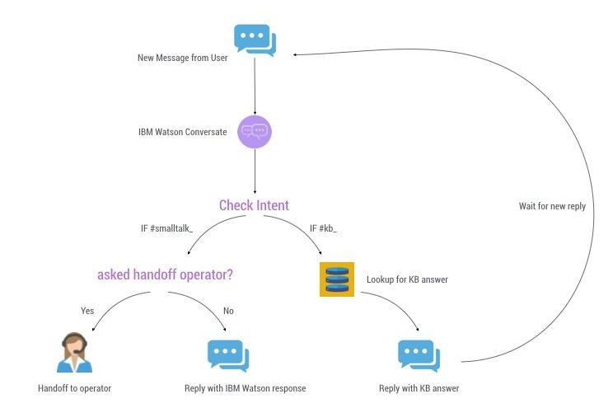

**Design Thinking:**

**Persona Design**

**Chatbot Name:** "InfoBot"

**Tone:** Friendly, informative, and approachable.

**Style of Communication:** Conversational, with a touch of humor where appropriate to make interactions more engaging and enjoyable.

User Scenarios

**● User Scenario 1: User Seeking General Information**

* User: "Tell me about your services."
* InfoBot: Provides an overview of the services offered.
  + **User Scenario 2: User Looking for Contact Information**
* User: "What's your contact information?"
* InfoBot: Shares contact details, including phone number, email, and office address.
  + **User Scenario 3: User Asking About Business Hours**
* User: "What are your business hours?"
* InfoBot: Provides the operating hours for each day of the week.

**Conversation Flow:**

* + **Welcome Message**
* InfoBot greets the user and introduces itself.
  + **Main Menu**
* User can choose from options like "Services," "Contact Information,"

"Business Hours," and "FAQs."

* + **Service Information**
* If the user selects "Services," InfoBot provides a brief description of available services.
  + **Contact Information**
* If the user selects "Contact Information," InfoBot shares contact details and offers assistance with directions if needed.
  + **Business Hours**
* If the user selects "Business Hours," InfoBot provides the hours of operation.
  + **FAQs**
* If the user selects "FAQs," InfoBot lists commonly asked questions and answers.
  + **Fallback Response**
* If InfoBot doesn't understand a user query, it politely asks the user to rephrase or offers to connect to a human operator.
  + **Response Configuration**
* Utilize Watson Assistant's intents, entities, and dialog nodes to recognize user queries accurately and maintain context during the conversation.
  + **Platform Integration**
* Integrate InfoBot with Facebook Messenger and Slack using the respective APIs to ensure seamless interactions on these messaging platforms.
  + **User Experience**
* Design clear and concise prompts to guide users through the conversation.
* Ensure that InfoBot's responses are informative and easy to understand. - Implement error-handling mechanisms to gracefully handle unexpected user inputs.
* Continuously improve the chatbot's performance based on user feedback and analytics.

**Conclusion:**

This document outlines the problem definition and initial design thinking for creating InfoBot, a chatbot using IBM Cloud Watson Assistant. The next phases will involve the implementation, testing, and refinement of the chatbot to ensure it meets its goals effectively.